Dual Coding Theory (A. Paivio)
Overview:
The dual coding theory proposed by Paivio attempts to give equal weight to verbal and non-verbal processing. Paivio (1986) states: "Human cognition is unique in that it has become specialized for dealing simultaneously with language and with nonverbal objects and events. Moreover, the language system is peculiar in that it deals directly with linguistic input and output (in the form of speech or writing) while at the same time serving a symbolic function with respect to nonverbal objects, events, and behaviors. Any representational theory must accommodate this dual functionality."
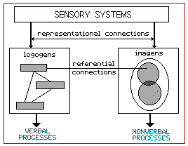
The theory assumes that there are two cognitive subsystems, one specialized for the representation and processing of nonverbal objects/events (i.e., imagery), and the other specialized for dealing with language.
Paivio also postulates two different types of representational units:
"imagens" for mental images and "logogens" for verbal entities which he describes as being similar to "chunks" as described by Miller. Logogens are organized in terms of associations and hierarchies while imagens are organized in terms of part-whole relationships.
Dual Coding theory identified three types of processing: (1) representational, the direct activation of verbal or non-verbal representations, (2) referential, the activation of the verbal system by the nonverbal system or vice-versa, and (3) associative processing, the activation of representations within the same verbal or nonverbal system. A given task may require any or all of the three kinds of processing.
Scope/Application:
Dual coding theory has been applied to many cognitive phenomena including: mnemonics, problem-solving, concept learning and language. Dual coding theory accounts for the significance of spatial abilities in theories of intelligence (e.g., Guilford). Paivio (1986) provides a dual coding explanation of bilingual processing. Clark & Paivio (1991) present dual coding theory as a general framework for educational psychology.

Allan Paivio
Dual Coding Theory
Biography
Paivio has a Ph.D. in Psychology, and has spent over forty years in research on imagery, memory, language, cognition, and other areas. He has published approximately two hundred articles and book chapters, and five books.
Theory
"Dual coding" implies that verbal and non-verbal systems are alternative internal representations of events. For example, one can think of a house by thinking of the word "house", or by forming a mental image of a house The verbal and image systems are connected and related, for one can think of the mental image of the house and then describe it in words, or read or listen to words and then form a mental image.
Verbal system units are called logogens; these units contain information that underlie our use of the word. Non-Verbal system units are called imagens. Imagens contain information that generates mental images such as natural objects, holistic parts of objects, and natural grouping of objects.
Imagens operate synchronously or in parallel; thus all parts of an image are available at once.
Logogens operate sequentially, words come one at a time in a syntactically appropriate sequence in a sentence.
The two codes may overlap in the processing of information but greater emphasis is on one or the other. The verbal and non-verbal systems are further divided into subsystems that process information from different modalities.
Paivio, A. (1986).
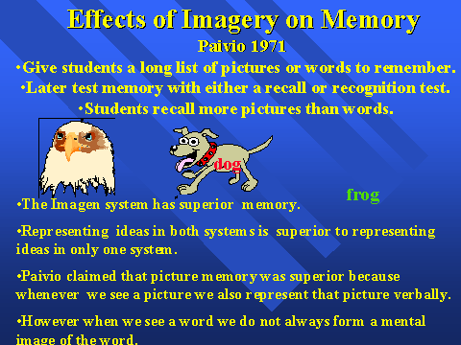
Experiment:
- Give students a long list of pictures or words to remember.
- Later test memory with either a recall or recognition test.
- Students recall more pictures than words
- The Imagen system has superior memory
- Representing ideas in both systems is superior to representing ideas in only one system.
- Paivio claimed that picture memory was superior because whenever we see a picture we also represent that picture verbally.
- However when we see a word we do not always form a mental image of the word.

